

East West University

Department of Computer Science & Engineering

**Course Title:** Database System

**Course Code:** CSE301  
**Experiment No:** 03

**Semester:** Fall, 2015

**Section:** 01

**Submitted By:**

S. M. Amirul Islam

ID: 2013-1-60-048

**Introduction**

Procedure:

* Open SQL Server Management Studio in computer
* Connect it to the server.
* Then we have to create new database and also new query.
* In the query window we have to write our commands.

**Lab Work**

**Data Table:**

|  |  |  |
| --- | --- | --- |
| **student** | | |
| **sid** | **sname** | **age** |
| 701 | AA | 20 |
| 702 | BB | 21 |
| 703 | CC | 20 |
| 704 | DD | 18 |

|  |  |  |
| --- | --- | --- |
| **employee** | | |
| **emid** | **emname** | **salary** |
| 902 | Asif | 10,000 |
| 1003 | Ana | 15,000 |
| 701 | AA | 12,000 |

1. Show student data.

**Ans:** select * from student

*Output:*

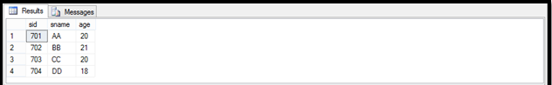

1. Show employee’s data.

**Ans**: select * from employee

*Output:*

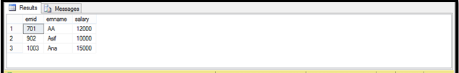

1. Show student ID.

**Ans:** select sid from student

*Output:*

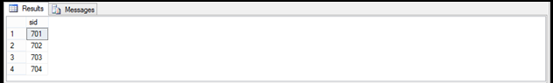

1. Show student ID and name.

**Ans:** select sid,sname from student

*Output:*

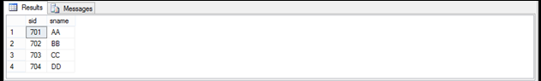

1. Show age of students.

**Ans:** select age from student

*Output:*

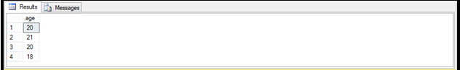

1. Show distinct age of students.

**Ans:** select distinct age from student

*Output:*

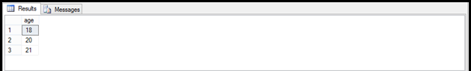

1. Show the ages of students.

**Ans:** select all age from student

*Output:*

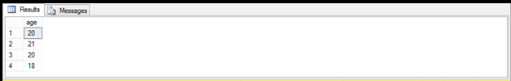

1. Show employee id and salary with multiplication of 10.

Answer: select emid,salary*10 as new_salary from employee

*Output:*

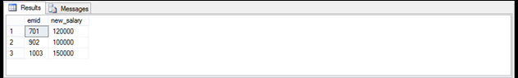

1. Show student name whose id is 701.

Answer: select sname from student where sid=701

*Output:*

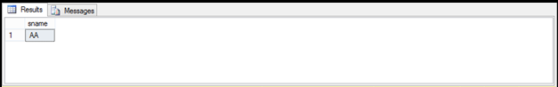

1. Show student id whose age is 20.

Answer: select sid from student where age=20

*Output:*

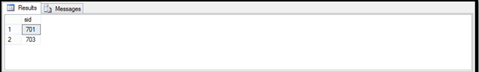

1. Show student age whose name is BB.

Answer: select age from student where sname='BB'

*Output:*

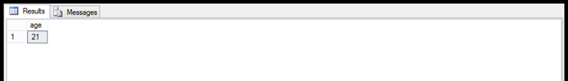

1. Show employee id and salary whose name is Asif.

Answer: select emid,salary from employee where emname='Asif'

*Output:*

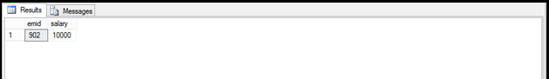

1. Show employee salary whose id is 1003

Answer: select salary from employee where emid=1003

*Output:*

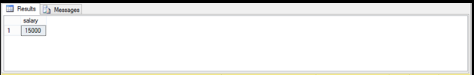

1. Show employee id whose salary is greater than 12000.

Answer: select emid from employee where salary>12000

*Output:*

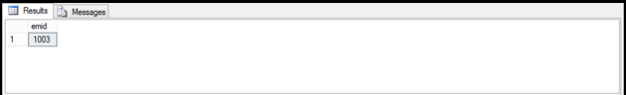

1. Show employee is whose salary is more than or equal to 12000.

Answer: select emid from employee where salary>=12000

*Output:*

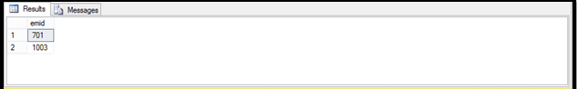

1. Show employee id whose salary is less than 12000.

Answer: select emid from employee where salary<12000

*Output:*

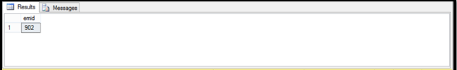

1. Show employee id whose salary is equal to 12000.

Answer: select emid from employee where salary=12000

*Output:*

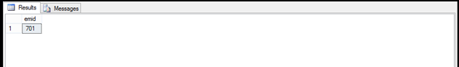

1. Show employee id whose id is more than 700 and salary is less than 15000.

Answer: select emid from employee where emid>700 and salary<15000

*Output:*

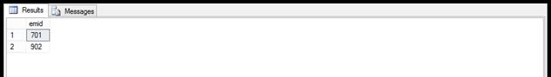

1. Show employee id whose salary is in between 10000 to 15000.

Answer: select emid from employee where salary between 10000 and 15000

*Output:*

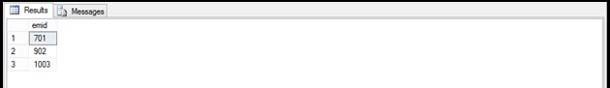

1. Show employee id whose salary is not between 10000 to 15000.

Answer: select emid from employee where salary not between 10000 and 15000

*Output:*

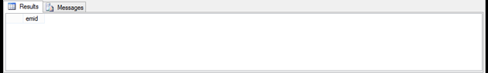

1. Show employee id, student id and student name.

Answer: select employee.emid, student.sid, student.sname from employee,student

*Output:*

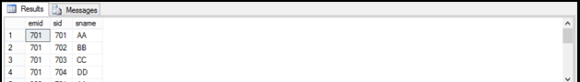

**Lab Exam**

1. **What is DML? Explain about it with example.**

**Answer:** Language for accessing and manipulating the data organized by the appropriate data model. DML is also known as query language.

Data manipulation languages have their functional capability organized by the initial word in a statement, which is almost always a verb. In the case of SQL, these verbs are:

* SELECT ... FROM ... WHERE ...
* INSERT INTO ... VALUES ...
* UPDATE ... SET ... WHERE ...
* DELETE FROM ... WHERE ...

For example, the command to insert a row into table employees:

insert into employee values(1003,'Ana',15000)

1. **What is the basic format of the query in SQL?**

**Answer:** A typical SQL query has the form:

*select A1,A2,…,An*

*from r1,r2,…,rm*

*where P*

Ai represents an attribute

Ri represents a relation

P is a predicate

**Data Table:**

|  |  |  |  |
| --- | --- | --- | --- |
| **St_id** | **St_name** | **St_address** | **Course_id** |
| 412 | Asif | Dhaka | Cse205 |
| 521 | Ana | Sylhet | Cse101 |
| 865 | Bobi | Rajshahi | Cse301 |
| 741 | Rupa | Dhaka | Cse205 |
| 895 | Asif | Dhaka | Cse301 |
| 746 | Robi | Sylhet | Cse101 |
| 845 | Nazrul | Sylhet | Cse301 |

|  |  |  |  |
| --- | --- | --- | --- |
| **Course_id** | **Course_name** | **Semester** | **Year** |
| Cse205 | Dmath | Fall | 2014 |
| Cse101 | Intro | Fall | 2012 |
| Cse301 | Database | Fall | 2011 |

1. **Query of Table:**

create table course(

course_id varchar(20) not null,

course_name varchar(20),

semester varchar(20),

yr int

primary key(course_id),

)

create table student1(

st_id int not null,

st_name varchar(20) not null,

st_address varchar(20),

course_id varchar(20),

primary key(st_id),

foreign key(course_id) references course

)

1. **Query of Data Entry.**

insert into course values('cse205','dmath','fall',2014)

insert into course values('cse101','intro','fall',2012)

insert into course values('cse301','database','fall',2011)

insert into student1 values(412,'asif','dhaka','cse205')

insert into student1 values(521,'ana','sylhet','cse101')

insert into student1 values(865,'bobi','rajshahi','cse301')

insert into student1 values(741,'rupa','dhaka','cse205')

insert into student1 values(895,'asif','dhaka','cse301')

insert into student1 values(746,'robi','sylhet','cse101')

insert into student1 values(845,'nazrul','sylhet','cse301')

1. **Show the student information who are enrolled in cse301**.

**Answer:** select * from student1 where course_id='cse301'

*Output:*

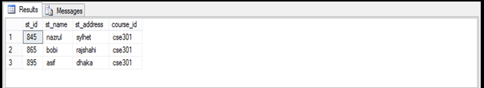

1. **Show the student information whose address is in Dhaka.**

**Answer:** select * from student1 where st_address='dhaka'

*Output:*

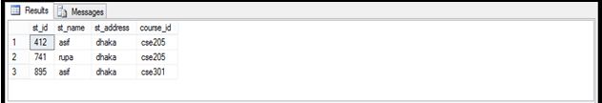

1. **Show the address of the students without duplication of the address.**

**Answer:** select distinct st_address from student1

*Output:*

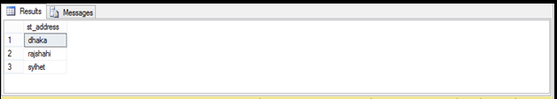

1. **Show the student name with address.**

**Answer:** select st_name,st_address from student1

*Output:*

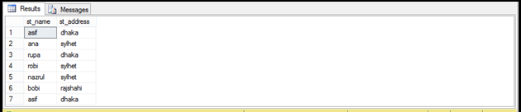

1. **Show the student id along with the course id.**

**Answer:** select st_id,course_id from student1

*Output:*

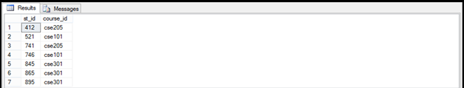

1. **Show the student names without duplication.**

**Answer:** select distinct st_name from student1

*Output:*

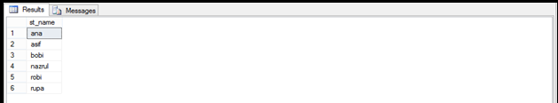

1. **Show the student names with duplications.**

**Answer:** select all st_name from student1

*Output:*

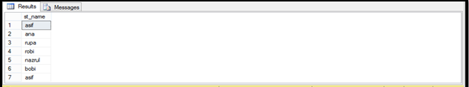

1. **Show the course information of the year 2014**

**Answer:** select * from course where yr=2014

*Output:*

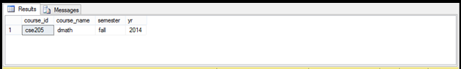

1. **Show the course information of the year between 2011 and 2012**

**Answer:**  select * from course where yr between 2011 and 2012

*Output:*

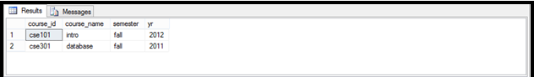

1. **Show the course name, semester of the course whose id is cse205**

**Answer:** select course_name,semester from course where course_id='cse205'

*Output:*

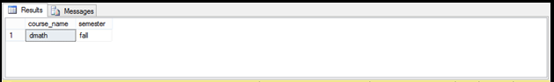

1. **Show the student information who are enrolled in cse101 and lives in sylhet.**

**Answer:** select * from student1 where course_id='cse101' and st_address='sylhet'

*Output:*

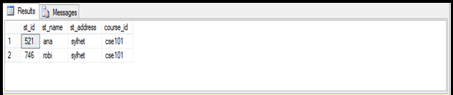

1. **Show the student id, name along with the course name they are enrolled in.**

**Answer:** select student1.st_id,student1.st_name,course.course_name from student1,course where student1.course_id=course.course_id

*Output:*

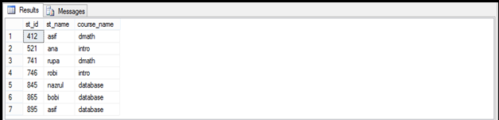

1. **Show the student id, name along with course id, semester and year.**

**Answer:** select student1.st_id, student1.st_name, course.course_name, course.semester, course.yr from student1,course where student1.course_id=course.course_id

*Output:*

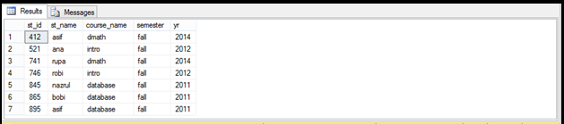

1. **Show the student id and course name of the students enrolled in semester fall 2012**

**Answer:** select student1.st_id,course.course_name from student1,course where course.semester='fall' and course.yr=2012 and student1.course_id=course.course_id

*Output:*

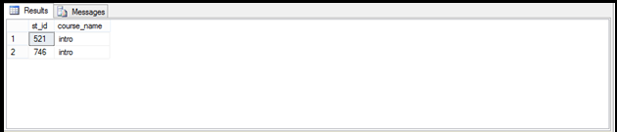

1. **Show the student id, name, address with their enrolled semester and year.**

**Answer:** select student1.st_id, student1.st_name, student1.st_address, course.semester, course.yr from student1, course where student1.course_id=course.course_id

*Output:*

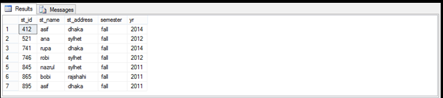

1. **Show the course id with name offered in not between 2011 and 2012.**

**Answer:** select course_id,course_name from course where yr not between 2011 and 2012

*Output:*

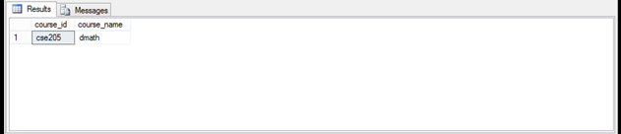

**Discussion:**

In this lab I have learned how to make command for various Data Manipulation using SQL query.